Blockchain of Secrets – Final Report

✅ Tools Used
- CyberChef – For decoding, hashing, and encryption/decryption
- FutureBoy Steganography Tool – For encoding & extracting hidden files from images

🔐 Final Flag:
AllDone

📝 Step-by-Step Report

🔹 Block 1: Steganography + Base64 Decoding
- Image File: SecPlus1.jpg
- Passphrase: StartHere
- Tool Used: FutureBoy Steganography Tool
- Extracted File: Secret-1.txt
- Contents of File: UGFuZGFFeHByZXNz
In CyberChef:
- Recipe used: From Base64
- Output: PandaExpress
📷 Screenshot of image upload and passphrase in Steganography tool
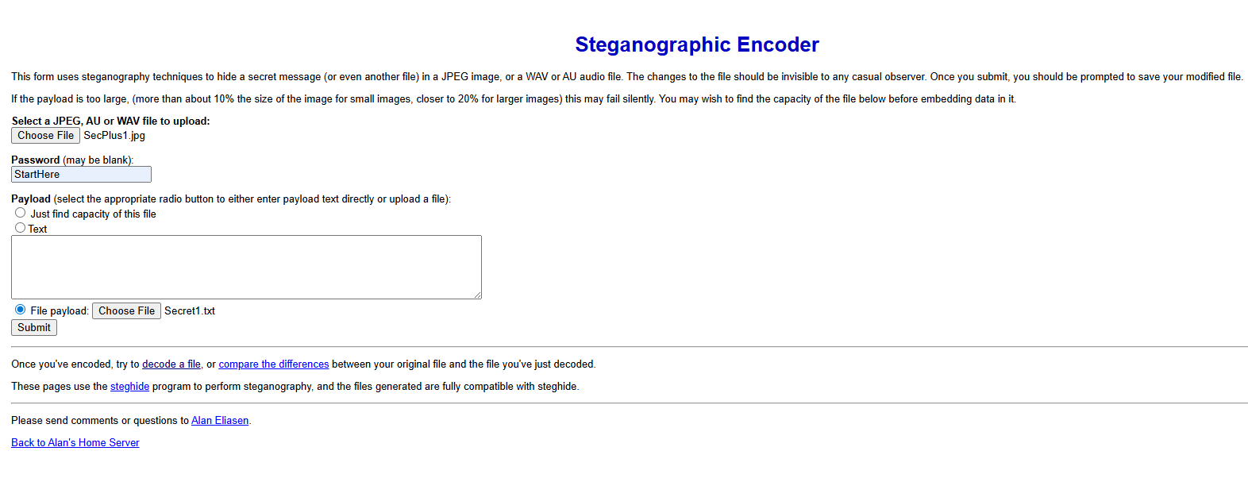
Once you hit “submit” the image(s) will download as “SecPlus1steg” etc.
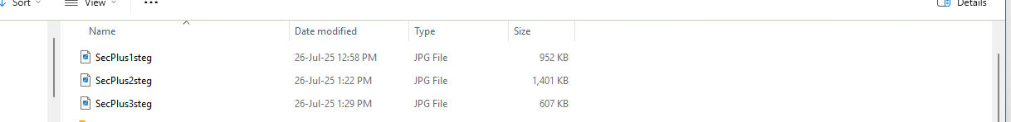
*** Now that you’ve encoded, try to decode a file and select the encoded image from downloads. Example: Choose file: “SecPlus1steg”
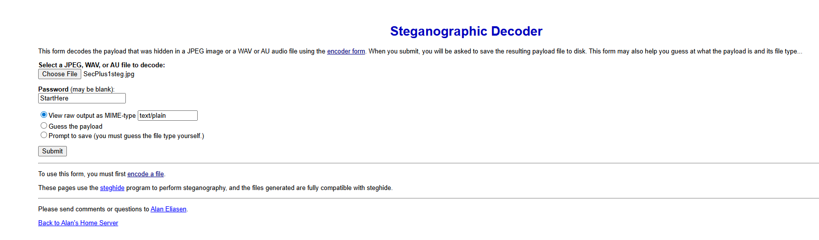
Click – “Submit” for the following output and repeat the decoding process for the remaining steps below.
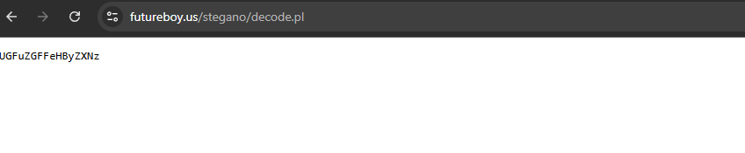
📷 - Screenshot of CyberChef with From Base64 recipe
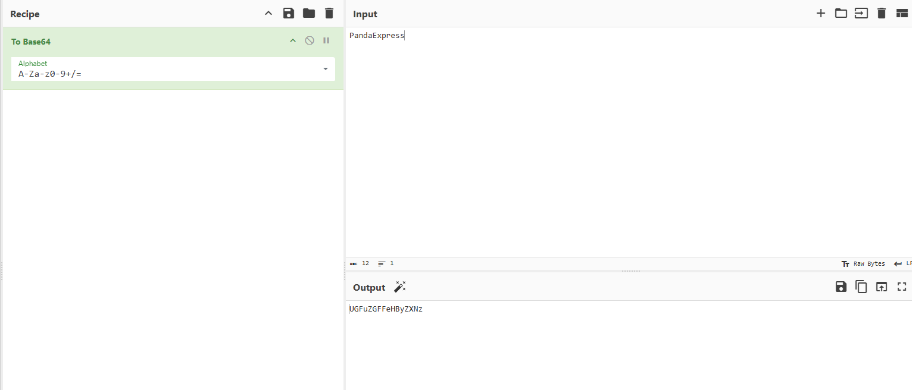
📷 Screenshot of Secrete1.txt 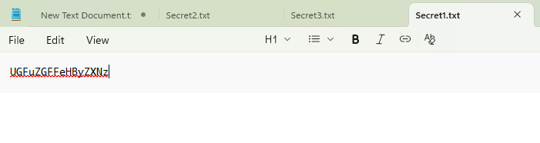
💬 Explanation:
Base64 encoding transforms binary data into a readable ASCII string. In this block, the hidden message inside the image was encoded in Base64, which I decoded in CyberChef to retrieve the key phrase for the next step.

🔹 Block 2: SHA3-256 Hashing
- Image File: SecPlus2.jpg
- Passphrase: PandaExpress
- Tool Used: FutureBoy Steganography Tool
- Extracted File: Secret-2.txt
- Contents of File: HappyFriday
In CyberChef:
- Recipe used: SHA3 (256 bit)
- Input: HappyFriday
- Output: b014789318473d9950698961e965c1c3af552dfbdba0dbb2ed47aba8c4f40692

📷 Screenshot of image upload and passphrase in Steganography tool
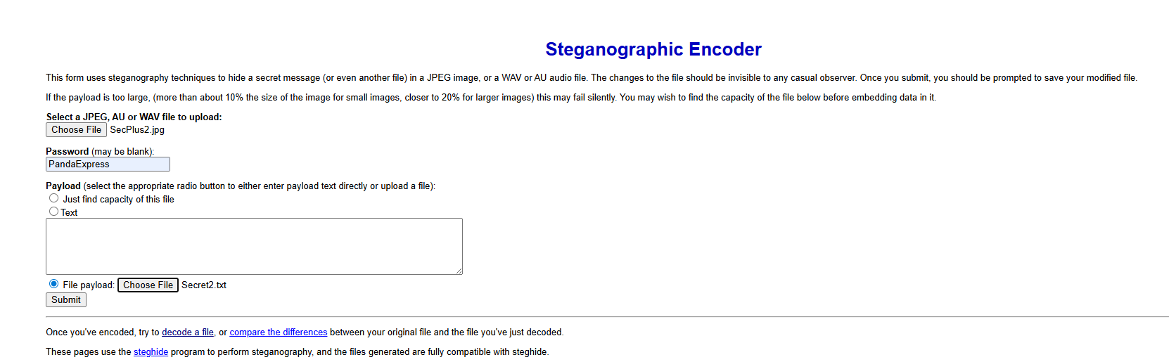
📷 Screenshot Secrete2.txt
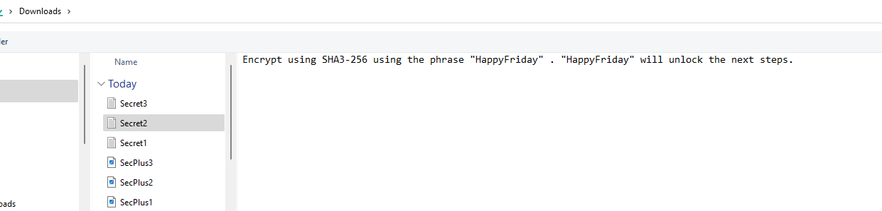
Screenshot of CyberChef with From SHA3-256 recipe
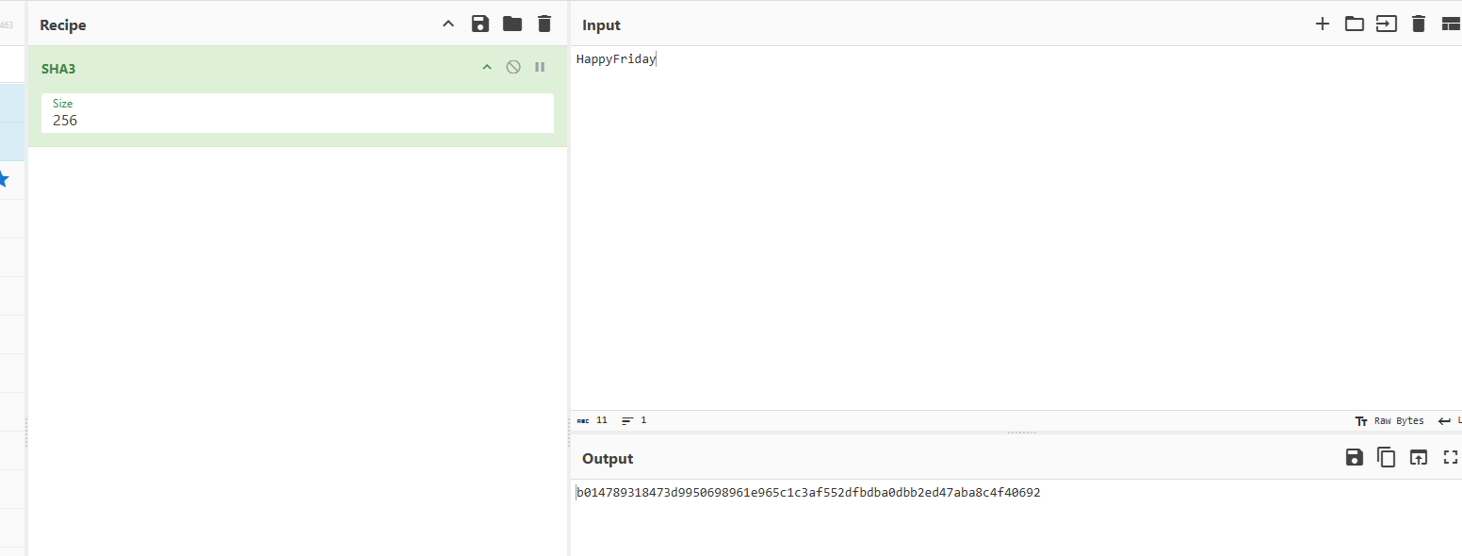
💬 Explanation:
Hashing using SHA3-256 creates a fixed-length fingerprint of a message. The phrase "HappyFriday" was hashed to generate a secure 256-bit key, which was later used as the symmetric key for AES decryption.

🔹 Block 3: AES Decryption
- Image File: SecPlus3.jpg
- Passphrase: HappyFriday
- Tool Used: FutureBoy Steganography Tool
- Extracted File: Secret-1.txt
- Contents (encrypted in hex): f56503282d2c63e95b979aececf79659
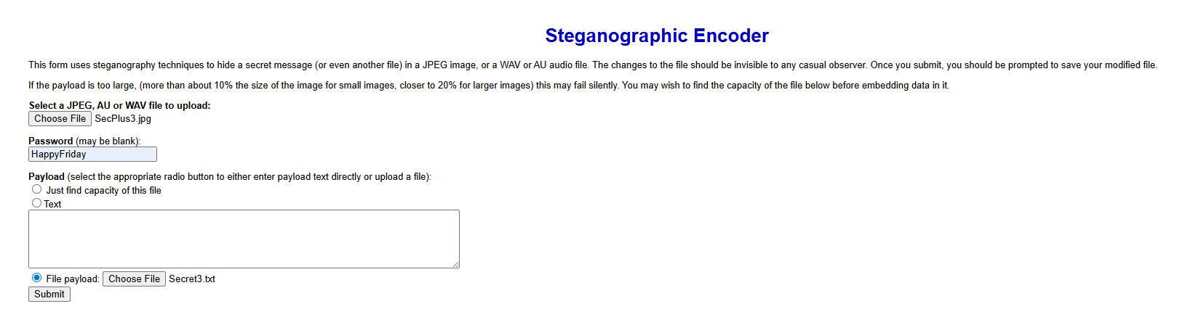
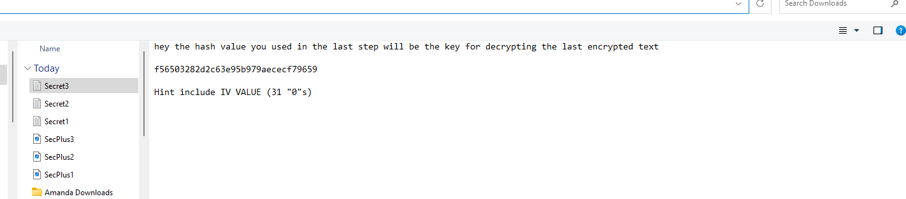
In CyberChef:
- Recipe used:
- AES Decrypt
- Mode: CBC
- Key (Hex): b014789318473d9950698961e965c1c3af552dfbdba0dbb2ed47aba8c4f40692
- IV (Hex): 00000000000000000000000000000000
- Output: AllDone
💬 Explanation:
Symmetric encryption (AES) uses the same key to encrypt and decrypt data. The AES key (a SHA3-256 hash of "HappyFriday") was used along with an IV of 16 zero-bytes to decrypt the final encrypted message and reveal the flag.

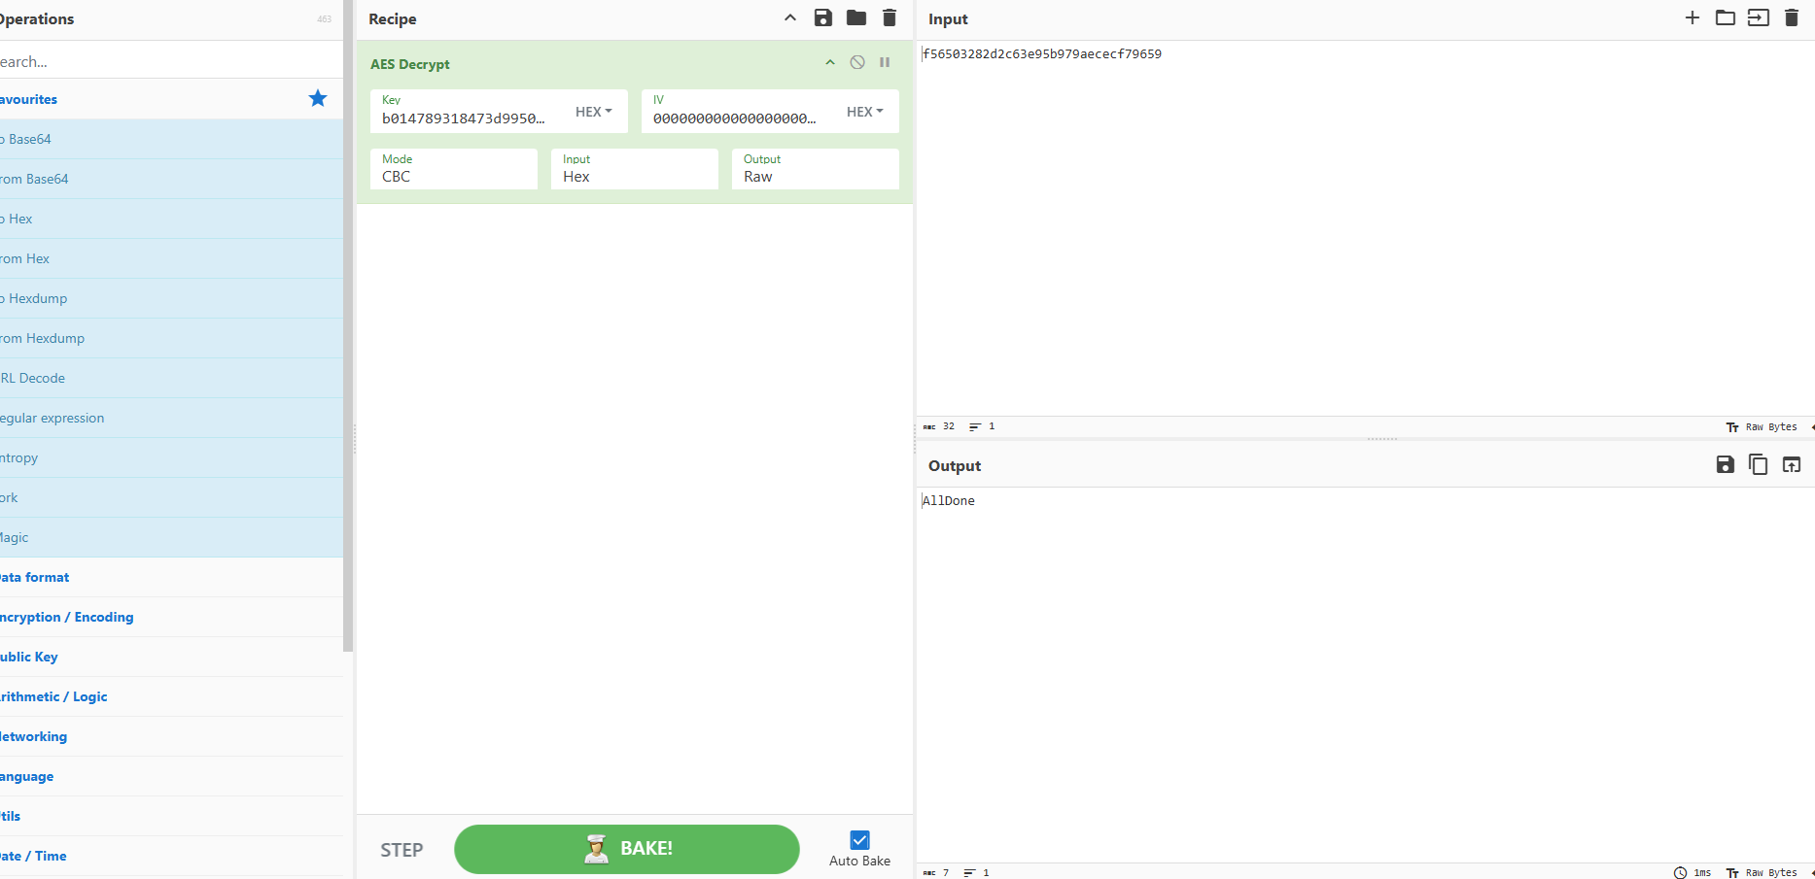

🧠 Reflection
The most challenging part of the project was choosing the right Steganography Tool to perform this project as some of the alternative tools do not have text conversion features. The command line gave me problems, so I used online sources. The video demonstration did not mirror the written instructions so there was some research and filling in the gaps on my end. This project gave me hands-on experience with how cryptographic methods—like encoding, hashing, and encryption—are layered together to protect data. I learned how steganography can hide files in plain sight and how hashes create secure, irreversible representations of input. AES encryption was the most powerful and final layer, requiring all previous steps to align for successful decryption. Overall, this project was a bit time consuming, however a fun and practical demonstration of how cybersecurity concepts work together in real-world applications.

📘 Lessons Learned
Throughout this challenge, I learned the value of collaboration and problem-solving. I reached out for a second pair of eyes and leveraged the expertise within my network to overcome technical blocks. Helpful tips included saving content properly into the text files so that it would appear clearly when decoded, ensuring the Initialization Vector (IV) for AES was correctly set to 31 zeros, and the importance of repetition—going back through steps when things didn’t work the first time. The project reminded me to stay persistent, stay curious, and most importantly, have fun with the process. These lessons not only helped me solve the challenge but also reinforced how real-world cybersecurity often requires both technical skill and teamwork.

